How I found my race in America

When I stopped smiling like a good immigrant, I risked becoming an angry brown woman
By Sharmila Sen AUGUST 17, 2018
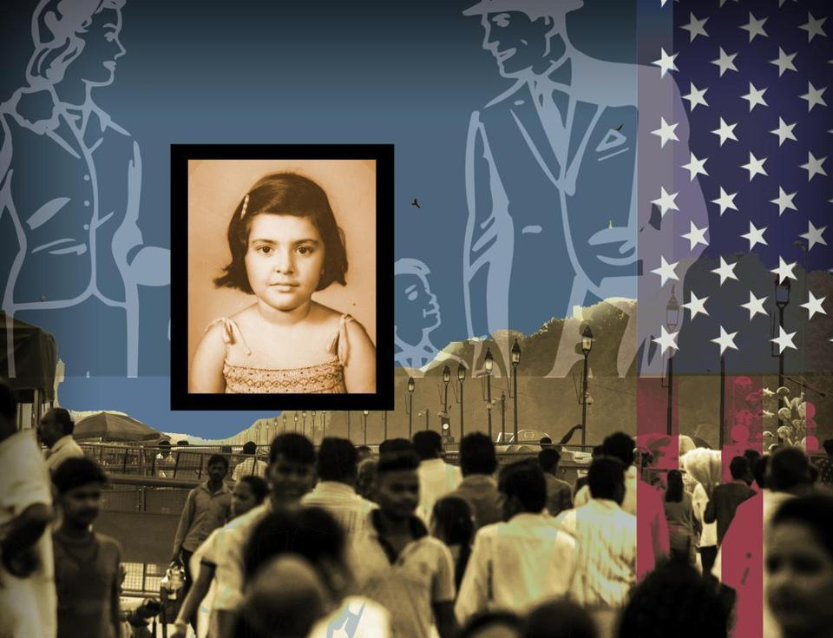
I tried to be the good immigrant by assimilating as swiftly as I could when I arrived in the United States as a young girl. I tried to be a grateful immigrant by learning to talk, dress, cook, eat, drink, dance, and even think like an American. Following the logic of meritocracy, I believed that my success was earned by merit. And my merit was my virtue. I was entrepreneurial. I fashioned myself to increase my chances of finding success. I wore whiteface. And just when my colleagues and friends simply “forgot” I was Not White — an unexpected tide of anger welled up inside me. Just when I thought I had succeeded in following the rules of my own DIY whiteface manual, I found myself angry and overwhelmed by sadness.
The angrier I felt, the more I smiled, told jokes, made others laugh so that they would not perceive me as a problem. I took care not to speak Bengali in front of others outside my family. I did not ask for a day off from work when Holi or Durga puja or Diwali rolled around. I participated in Christmas festivities with great enthusiasm. In truth, I enjoyed wrapping Christmas presents, surprising colleagues with the perfect Secret Santa gifts, and drinking eggnog. I enjoyed the sharp, clean scent of pine when I stood in the snow, selling Christmas trees for our children’s school fund-raisers. Having lost all the festivals of my youth I was eager to mark the seasons in any way possible — Halloween, Thanksgiving, Christmas, Valentine’s Day, Easter. There is comfort in rituals that mark the rhythm of each season. And it was also my way of blending into the dominant culture.
I wished to blend into whiteness because I knew how the poor, the foreign, the underclass are only too visible. I knew how the dominant class averts its gaze and continues to surveil those who are marked out as different, weak, and dangerous. As a young girl in India, I was trained not to see the things that terrified us — the beggars on the streets, the refugees on railway platforms. Our self-inflicted blindness was less a mark of our callousness, and more a sign of our terror. The distance between me and the girls who begged on the streets was so fragile. We did not truly see the maids, cleaners, drivers, and doormen. We did things when our maids were in the room, or when a driver was in the car, that no human normally does in front of another. The master often does not see the slave; the mistress of the house does not see her maid; and I did not see the women who squatted in our kitchen and washed dirty dishes. We did not really see them because they were not quite human to us. So we felt free to carry on as if no one was around.
Our blindness was also an indicator of the outsize importance of the people we chose not see. In Calcutta, Ma and Baba constantly fretted about thieves, kidnappers, and pickpockets. We demonized everyone who came out of that unseen place behind the garbage heap. Today I realize that my blindness was to the particularity of the slum dwellers and beggars I saw all around me. I did not see individual human beings. Instead, I saw supersized generalizations: slum dwellers, lower classes, untouchables, kidnappers, thieves, robbers, servants. Each of these words in Bengali exceeds its dictionary definitions. They are not mere nouns but diffuse, scary ideas used to make a middle-class child obey her elders, ace her exams, and never let go of an adult’s hand in a crowd. These words were our own Bengali version of the quintessential American phrase my children have been taught by well-meanings teachers — stranger danger.
Strangers pose danger. I knew that in Calcutta long before I learned this cute English phrase. They can cheat us, rob us, steal us, maim us, and even slit our throats while we sleep in our beds at night. We locked and bolted every door and window at night when we went to sleep. A watchman patrolled Dover Lane and the familiar sound of his bamboo stick hitting the pavement — thak, thak, thak — lulled me to sleep. Strangers were dangerous because they could transform us into people like them. We had to remain alert and not look too closely into their eyes.
In New Haven, I was once warned by a fellow student that I had to be careful when walking around town. “Sometimes,” this white classmate told me, “you turn a corner and realize you are the only white person walking on the street. Be careful.” An awkward pause followed. I walked back to my apartment, muttering to myself about all the things I could have said in response. “I always forget you are Indian,” a high school friend told me while we were walking around Harvard Square. She meant it as a compliment. She meant I was not a strange foreigner. That made me even sadder. “But I see you as white,” a dear friend confided to me during a work trip to India. We were sitting together on the rooftop of a small house in a Rajasthani village. Perhaps my friend intended to convey that she perceived no difference between us. Perhaps she did not want to see us as separate. In America, separateness is always accompanied by the specter of inequality. I, who had worked for so long to hide my difference, felt suffocated by the embrace of sameness. Sitting atop an impoverished home in India, looking at the stray dogs, scrawny cows, and mud-caked water buffaloes, with the dusty Aravalli Hills undulating in the distance, I no longer yearned to be seen as white, no matter how pale my skin appeared. I did not wish to leave behind my fellow Indians — even the ones with whom I had few words or foods or gods in common — in their poorly constructed homes, surrounded by heaps of trash and open drains, and disappear into whiteness.
“But I see you as white.” This is a veiled compliment. The speaker intends to say, “We will let you be on our team. For now. There will be conditions attached in fine print. Ignore them at your own peril.” “But I see you as white.” My husband and children have darker brown complexions. My parents’ English still carries faint traces of their mother tongue. My Sikh father-in-law wears a turban and has never trimmed his beard. My grandmothers wore saris every day. My aunts carefully placed a red vermilion dot on their foreheads each morning and blew on a conch shell to welcome Durga each autumn. My ancestors were barred from entering European clubs in colonial India, jailed by the British for demanding independence, and designated as terrorists by the British Empire. In the United States, Indian men and women were legally barred from naturalization until the 1940s. “But I see you as white.” Would the same be said of all of them?
I am the kind of Not White that makes human resource managers happy. I blend into whiteness when it is convenient for everyone else in the office. My presence increases diversity when the company is required to present official tallies of minority employees. When we attend conferences, my employers can suggest that I apply for financial aid reserved for minorities in my profession. My Not Whiteness can improve an accountant’s bottom line. I am Not Quite Not White. The kind of Not White who makes inclusion look easy and does not make people uncomfortable with her behavior. That is, until someone reads a newspaper article about unemployment in America, or listens to a political speech about the evils of outsourcing, or tunes into a radio program about Asians crowding American universities, or watches a television show about Indians winning the national spelling bee yet again. When this happens, I am just Not White enough to become the scapegoat. I am the immigrant who stole the jobs, the minority who gamed the system to snatch away someone else’s rightful place in college, the brown person who is unnaturally good at spelling unusually difficult English words.
The smiling member of the model minority can seem uppity in a heartbeat. During our interview at the US Consulate in Calcutta, I wish they had told me that I must avoid this sin at all costs if I were to be granted a visa. They should have told me to keep my success within limits, my intelligence in check, and my latent uppitiness under control. I would be at my most pleasing as long as I remained the salutatorian, the runner-up, the solid A minus, the magna cum laude, the Not Quite.
When white people simply “forgot” I was Not White, I did not want to smile any longer. I did not want to be the entertainer. I did not want to be the storyteller who spins a yarn as the earth flows somber under an overcast sky. In Joseph Conrad’s Heart of Darkness, Charlie Marlow proclaimed that England, too, was once a place of darkness. I felt very clever when I first detected that line. In a building in Harvard Yard named after a famous American Transcendentalist, I used to teach this very line to my students, pleased with myself for having mastered the literary code of those who once colonized my ancestors. Now, I want that darkness back for myself. I do not wish to accord to white Europeans that which was once used to justify the plunder and conquest of Asia, Africa, and the Americas.
I reclaim the heart of Not Whiteness for myself and my children. Race, once a puzzling, ugly, comic, ill-fitting concept, I realize today, was the immigrant. I chose to make it native to myself. Going against the grain of my education, I decided to naturalize the very concept I once historicized with clinical precision. My Indian past was my way of keeping race at arm’s length when I was new to this country. When I became the mother of three children, the future demanded something new of me. The immigrant’s story is often written by the second or third generation in America. The American-born child gives birth to the foreign-born parent. Elsewhere is assimilated into the here. The foreign plot is domesticated into the national mythology. Those of the first generation are often too tired, too afraid, too new to English to write their own story. They are busy being good immigrants. When I stopped smiling like a good immigrant, I risked becoming a bad American, an ungrateful immigrant — an angry brown woman. The smile was my road to becoming American. I did not know I would find anger at the end of the journey.
I did not become American by speaking with the right accent, or by dancing to Prince and Salt-N-Pepa, or by eating my steak medium rare and drinking my bourbon neat. Those acts merely Americanized me. And to be Americanized is precisely not to be American. I did not become American when I passed the naturalization exam, renounced my Indian citizenship, and swore allegiance to the flag in Boston’s historic Faneuil Hall. I became American by becoming Not White.
Sharmila Sen is executive editor-at-large at Harvard University Press. This story is excerpted from “Not Quite White” by Sharmila Sen, to be published on August 28, 2018, by Penguin Books, a division of Penguin Random House LLC. Copyright 2018 by Sharmila Sen. Send comments to magazine@globe.com.

