Justification: This week we read the article "I'm Successful Because I'm Beautiful" — How We Discriminate by Ray Williams in Psychology Today. This article described the how the success of some people is directly tied to how effective they are at attracting other people. While reading this article we were supposed to reflect on how the emphasis on beauty is constantly referenced in The Epic of Gilgamesh, and how that beauty may allow the protagonist to succeed in his adventures. I decided to test whether beauty actually allows someone to be more successful in five areas: manipulation, intelligence, financial gain, leadership, and pure strength.
Questions: To create different levels of beauty that aren’t too subjective I chose to use three different pictures of the same actor in similar clothing and utilized those pictures to have people answer questions that might show their success in the areas I chose.
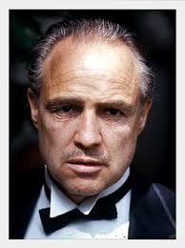

1. Which of these people would be most successful in changing your mind about something you’ve already decided?
2. If these three people were arguing about something, which one would most likely be correct?
3. If each of these people were trying to sell you a car, which one would you buy it from?
4. Which one of these men is a decorated military veteran who successfully led men into battle?
5. If you were to get into a fight, which of these men would you want to back you up?
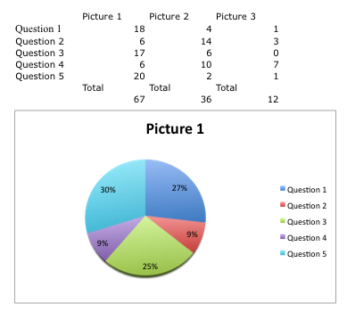
Audience: I chose to do this survey in the cafeteria during lunch; I walked around asking people the questions and tried to ask equal numbers of boys and girls.
Data Analysis: I surveyed 23 people in this survey, for every boy I asked to do the survey I tried to ask a girl. 8 of the people I surveyed were friends of mine.
Conclusion: This data shows that the youngest and most attractive Marlon Brando would be most successful in all areas. He might not be the most successful in certain areas like intelligence and leadership but when you look at the totals in the data he will be successful most of the time and much more successful than the unattractive and old Marlon Brando. This means that the emphasis on Gilgamesh’s beauty and how successful he was in the Epic are accurate, and that though attractive people might not always be successful, they are more likely to be successful than unattractive people. This also means that even when dealing with very similar people, in this case the same person; we are more likely to be compelled by their beauty than their actual ability or merits.
Flaws:
-This survey relates beauty to age, which might not always be true.
-People may have recognized Marlon Brando and made certain selections based on age.
-The questions I chose are vague, and we don’t know why people chose their answers. They might have been focused more on age than beauty.
-I had friends and mostly freshman and sophomores answer my survey, adults may skew the results. Students may just simply prefer people who are like them.

